**Brooklyn torah gazette**

**For parshas nasso 5783**

Volume 7, Issue 37 (Whole Number 344) 14 Sivan 5783/ June 3, 2023

**Printed L’illuy nishmas Nechama bas R’ Noach, a”h**

For a free subscription, please forward your request to [***keren18@juno.com***](mailto:keren18@juno.com)

**The Mystery of Ovadiah of Oppido, the Norman Convert**

**By**[**Sara Menucha Peltz**](https://www.chabad.org/search/keyword_cdo/kid/31817/jewish/Peltz-Sara-Menucha.htm)



***Art by***[***Sefira Lightstone***](https://www.chabad.org/3159160)

*Ovadia the Convert is a fascinating personality. A former member of the Christian clergy, he traveled to the Islamic lands, where he was able to convert to Judaism and study Torah. A witness to the murderous crusades, he became an accomplished scholar, who composed several liturgical poems. His life story and literary contributions have been preserved, in part, in the Cairo Genizah.*

**A Puzzling Piece of Papyrus**

Elkan Nathan Adler was puzzled. As the first European to enter the Cairo Genizah, he was in possession of a huge and extremely rare collection: 25,000 ancient manuscript fragments. One of those fragments appeared to be a strange “marriage” between the Jewish and Christian worlds.

It was a beautifully composed elegy for Moses, titled “Mi Al Har Chorev,” composed of six rhyming couplets, written in perfect, elegant Hebrew letters. Adler supposed that it had been written for the holiday of Shavuot or perhaps Simchat Torah. But above each delicately inscribed line, hovered musical notation that obviously originated from the Italian Church.

Adler dispatched the fragment to the Benedictine fathers of Quarr Abbey, situated on the Isle of Wight off the coast of Britain. Perhaps they would be able to identify the notation and shed some light on the rare find. The priests’ decisive response arrived during April 1918: The music notes were Lombardic style neumes (predecessors of today’s notes and staves) used by European Christians in the late 12th and early 13th centuries.

Compounding the mystery was the fact that the style of the Hebrew lettering could not be attributed to any location in Europe. Moreover, the paper itself was thick, slightly tan, and clearly Egyptian—a type used in many Genizah manuscripts of the 12th century.

**Considered a Rare Treasure**

The manuscript fragment was considered a rare treasure, puzzling scholars and students for decades. In 1947, famed musicologist Eric Werner examined it, and made a highly accurate transcription of the neumes:

*Its style is closely akin to that of the Gregorian plainsong Church, if we disregard one or two embellishments which seem alien to Gregorian style … Of course, the fact that our manuscript is so similar to Gregorian tunes is not surprising since it is today proved beyond any … doubt that the root of Gregorianism lies in the music of Palestine and Syria …*

He then quoted a Catholic musicologist, Father Dechevrens:

*Gregorian chant is the music of the Hebrews, and there is for the totality of the Roman Catholic melodies but one modal system – not that of the Greeks, but of the sacred nation of the Hebrews.*

**A Clearly Jewish Piyyut**

In short, both Werner and Dechevrens admit that it is not so strange to see church notations associated with a clearly Jewish *piyyut* (poem), as their original source was the “sacred nation of the Hebrews” to begin with. He almost seems to imply that the fragment proved that Gregorian chant, although used in the church still today, was applied to Jewish *piyyutim* and sung in synagogues during the middle-ages, independent of any Christian influence.

But there is a more powerful, likely explanation for the odd manuscript, which lies with its author.

In November 1964, Professor Norman Golb made a tremendous discovery. He took it into his head to compare the handwriting of the mysterious *piyyut* with that of another piece of parchment from the Genizah. It matched. The author of both fragments was a Jewish convert named Ovadia HaGer (Ovadia the convert), formerly Johannes of Opiddo.[1](javascript:doFootnote('1a5954242');)

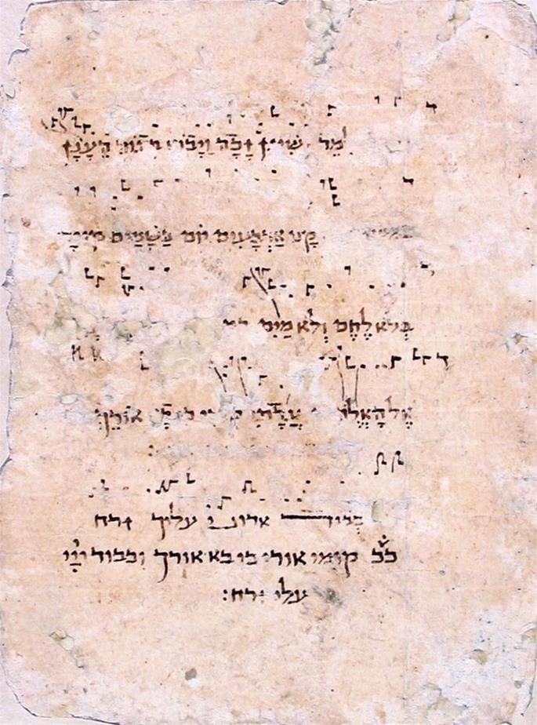

**Manuscript from the Cairo Geniza of “Mi Al Har Chorev,” held at the JTS library.**

**An Unlikely Inspiration**

In approximately 1070, twin boys were born to Dreux and Maria, residents of Oppido Lucano, Italy. They named the elder Rogerius and the younger Johannes. Dreux was a Norman nobleman, and Rogerius, as the scion of the household, was sent to learn the arts of war and chivalry. His younger brother was designated as the family scholar and sent to study priesthood.

While still a young child, Johannes heard of a mind-boggling occurrence: The Archbishop of Bari (a Roman Catholic archdiocese in southern Italy), Andreas, had converted to Judaism. The high-profile proselyte didn’t only send shockwaves through the mind of the youngster; a range of Church officials of varying strands of Christianity were also astonished. Johannes writes in his memoirs (the primary source of this information) that, “The Greek sages and the sages of Rome were ashamed when they heard the report about him.”

Andreas had left Bari, forsaking his homeland, his priesthood, his following, and his glory, and headed to Islamic Constantinople (Istanbul) where he underwent a *brit milah*(circumcision). His life from that day onward was dogged with hardship—particularly non-Jews who pursued him with violent intent—but G‑d consistently saved him from their designs. He was pursued not only because he had brought dishonor upon the Church, but also likely because of the large number of non-Jews who converted following his example.

Andreas eventually left Constantinople and journeyed to Egypt where he lived out the rest of his days.[2](javascript:doFootnote('2a5954242');)

Shortly after hearing of the extraordinary events concerning the Archbishop, young Johannes had a strange dream. He envisioned himself serving as a priest in Oppido when he saw a man standing to his right, opposite the altar. The man in his dream called his name, “Johannes!” What the vision subsequently said has been lost to history, as the fragment found in the Cairo Genizah was torn. It is safe to conclude, however, that it had something to do with the previous account of Andreas that Johannes recorded. Possibly, the man commanded him to become a Jew as well.

Nevertheless, it was 20 years before Johannes himself converted to Judaism. How he spent that time remains a mystery. It is assumed that he furthered his studies in the Church.

**A Crusade Against Judaism**

The next fragment of Johannes’ memoirs discusses the first crusade. He was approximately 30 years old at the time.

He describes an eclipse which took place in February of 1095 or 1096 as being an important omen for the evil to come. He quotes the prophet Joel:

*The sun shall turn into darkness and the moon into blood before the arrival of the great and awesome day of the L‑rd.**[3](javascript:doFootnote('3a5954242');)*

He describes the Frankish soldiers questioning among themselves why they bothered to travel to Jerusalem to fight their enemies, while their own hometowns harbored heretical foes. This kind of sentiment was what spurred the anti-Jewish actions of crusaders. Golb writes, “It is clear that he knew of the persecutions and possibly was a witness to some of them.”

A few years later, Johannes converted to Judaism, assuming the name Ovadiah. He probably chose the name Ovadiah because [Ovadiah](https://www.chabad.org/library/bible_cdo/aid/15761/jewish/Ovadiah-Obadiah.htm" \o "Ovadiah (Obadiah)) the Prophet was said to have been a Jewish convert from Edom.[4](javascript:doFootnote('4a5954242');) His inspiration to embrace Judaism seems to have been a combination of Andreas’s example and his own long-term immersion in the false teachings of the Church.

His disillusionment with the teachings of Christianity is confirmed by a letter of recommendation penned by Rabbi Baruch of Aleppo, Syria, on his behalf. Ovadiah described his noble ancestry to the rabbi, and related that due to “what he read in the books of their error, he returned to the L‑rd of Israel with all his heart, with all his soul and with all his strength … ”

When he arrived at the *beth din* (Jewish court) in order to convert, the judges questioned his motivation. The Jews were “in sorrow, oppressed, despised and scorned,” they said. The first crusade, which he himself witnessed, should have been a more than adequate deterrent for any potential convert.

Ovadiah replied that he knew it well enough, but that he came only out of love for the Jewish nation. Having ascertained that his motives were pure, the judges warned him about the strict [Torah](https://www.chabad.org/library/article_cdo/aid/1426382/jewish/Torah.htm) prohibitions he would have to observe, but cushioned them with descriptions of the reward he would accrue for keeping the mitzvot as a Jew. When he accepted the conditions, they immediately circumcised him, and when he had healed, he completed his conversion with a dip in the mikvah.

The letter concludes with an injunction that the reader should be careful to respect and refrain from causing harm to Ovadiah, because someone who wounds the feelings of a convert transgresses three negative commandments, and someone who oppresses him, infringes upon two. The purpose of the letter is also clarified: “That it might be kept by Ovadiah the Convert in all communities of Israel to which he might go.”[5](javascript:doFootnote('5a5954242');)

This letter was likely put to good use, as Ovadiah soon took to the road, destination: Baghdad.

**Persecution in Baghdad**

On his way to Baghdad, Ovadiah narrowly escaped a fleeing army which attempted to harm him. When he arrived at the city, once again his life was put at risk. In an era where every day brought news of Crusader success, it was not surprising that the local Muslims wanted to kill the light-skinned Norman on sight.

He eventually escaped and reached the Jewish community, where he waited at the door of one of the synagogues. He was given a room to board in a synagogue and provided with food. After some time, Rabbi Yitzchak, one of the Torah teachers, directed him—like the legendary Rabbi Akiva—to sit at the back of the classroom to learn the aleph-bet, Chumash and Tanach along with the children.

During the time Ovadiah spent in their community, the Baghdadi Jews endured much suffering at the hands of their overlord, Vizier Ibn al-Shuja. After numerous attempts to wipe them out failed, he imposed a special headgear, lead necklace and belt to be worn by every Jewish man. Every Jewish woman had to wear unmatched shoes – one red and one black – and a small, brass bell, either around her neck or on her feet.

He appointed gentile male and female oppressors to concoct ways to afflict them further. He also levied taxes upon them. If a Jew would die having not paid his tax, his body would not be released for burial before the taxes were paid. If a Jew died penniless, he would have to be redeemed by his brethren, otherwise the local non-Jews would have him cremated.

**Ovadiah’s Travels**

After a sojourn of several years in Baghdad, Ovadiah decided to return to Syria. He described arriving in Aleppo during the siege of Roger of Antioch, (circa 1118 CE). He also relates how, to his deep gratification, the Jewish community of Damascus put up a collection for him and supported him while he remained with them. In 1121, Ovadiah left Damascus for Banias, to the north of Israel. There he engaged in a fascinating discussion with an apparently eccentric Karaite named Solomon ibn Ruji, who claimed to be Moshiach. Solomon predicted that [Jerusalem](https://www.chabad.org/library/article_cdo/aid/4246466/jewish/Jerusalem.htm), then in the hands of the crusaders, would be liberated in two and half months! Ovadiah, not easily taken in, asked an incisive question:

“I have heard that you are a descendent of Aharon the Kohen. Now, today it is 19 years since I converted, but I have never heard that the Jews are seeking salvation through a [Kohen](https://www.chabad.org/library/article_cdo/aid/762109/jewish/Raise-Your-Hand-If-Youre-A-Kohen.htm) or Levi, but rather through Eliyahu Hanavi and King Moshiach, who descends from King David … ”

He then asked Solomon to give time a sign to prove his claim.

The imposter casually responded, “I do not eat bread, nor do I drink water!”

Ovadiah did not stop there. He pressed him, “So, what do you eat?”

Solomon proceeded to outline a generous diet! “Pomegranates, figs, almonds, nuts, sycamore-fruit, dates and apples which grow from trees and shrubs, and I drink milk.”

Ovadiah must have revealed his plans of continuing on to Egypt, because Solomon tried to persuade him to head to Israel and await the ingathering of the exiles, which he would soon orchestrate. Ovadiah declined, informing Solomon that he would proceed to Egypt and return to the Holy Land with the Egyptian Jews.

Solomon had no rejoinder.

Considering the clearly Egyptian paper upon which he wrote his memoirs, and the fact that they were eventually found in the Cairo Genizah, it is clear that Ovadiah did indeed arrive in Egypt. In addition to his fascinating diary, he recorded a number of beautiful piyyutim: *Mi Al Har Chorev* – “Who on Mount Sinai” in praise of Moses, *Baruch HaGever Asher Yiftach BaHashem*– “Praised is the man who trusts in [G‑d](https://www.chabad.org/library/article_cdo/aid/433240/jewish/God.htm),” and *V’aida mah* – “That I might know!”—a plea that he should “know what to speak within the gates … teach me!”

All of these poems have Lombardic musical notation, a fact which originally puzzled numerous scholars. But knowing who Ovadiah was immediately solves the riddle: an Italian monk, familiar with the classic Church musical notation, who converted to Judaism. When he wrote his beautiful Judaic poetry, he knew only one method of recording the melody to accompany it – the notation of his youth.

**FOOTNOTES**

[1.](https://www.chabad.org/library/article_cdo/aid/5954242/jewish/The-Mystery-of-Ovadiah-of-Oppido-the-Norman-Convert.htm" \l "footnoteRef1a5954242) Obadiah the Proselyte: Scribe of a Unique Twelfth-Century Hebrew Manuscript Containing Lombardic Neumes, *Norman Golb.*

[2.](https://www.chabad.org/library/article_cdo/aid/5954242/jewish/The-Mystery-of-Ovadiah-of-Oppido-the-Norman-Convert.htm" \l "footnoteRef2a5954242) The Autograph Memoirs Of Obadiah The Proselyte Of Oppido Lucano And The Epistle Of Barukh B. Isaac Of Aleppo, *Norman Golb*and Obadiah Memoir, *Obadiah the Proselyte*aka Megillat Ovadia HaGer *Ovadia HaGer.*

[3.](https://www.chabad.org/library/article_cdo/aid/5954242/jewish/The-Mystery-of-Ovadiah-of-Oppido-the-Norman-Convert.htm" \l "footnoteRef3a5954242) [Joel 4:4](https://www.chabad.org/16172#v4).

[4.](https://www.chabad.org/library/article_cdo/aid/5954242/jewish/The-Mystery-of-Ovadiah-of-Oppido-the-Norman-Convert.htm" \l "footnoteRef4a5954242) Sanhedrin 39b.

[5.](https://www.chabad.org/library/article_cdo/aid/5954242/jewish/The-Mystery-of-Ovadiah-of-Oppido-the-Norman-Convert.htm" \l "footnoteRef5a5954242) Epistle of R. Barukh of Aleppo, *Rabbi Baruch of Aleppo.*

*Reprinted from last week’s website of Chabad.Org*

**Thoughts that Count for Our Parsha**

*So shall you bless* (Num. 6:23)

The Torah's commandment to the kohanim (priests) was not meant as a command to bless the Jewish people but as an instruction how, i.e., in such and such a manner shall you bless them. For kohanim are by nature loving and giving; there was no need to order them to bless, merely to tell them what form it should take. (Rabbi Avraham Mordechai of Gur)

*May the L-rd bless you and keep you* (Num. 6:24)

The priestly blessing is in the singular tense, directed to each and every individual Jew. For the most important blessing they can receive is unity, that they join together as one person with one heart. (Olelot Efraim)

*Reprinted from the Parshat Nasso 5760/2000 edition of L’Chaim.*

**The Giving of One’s “Best”**

**Fruits to the “House” of G-d**

**From the Teachings of the Lubavitcher Rebbe**

**Rabbi Menachem Mendel Schneerson, Zt”l**

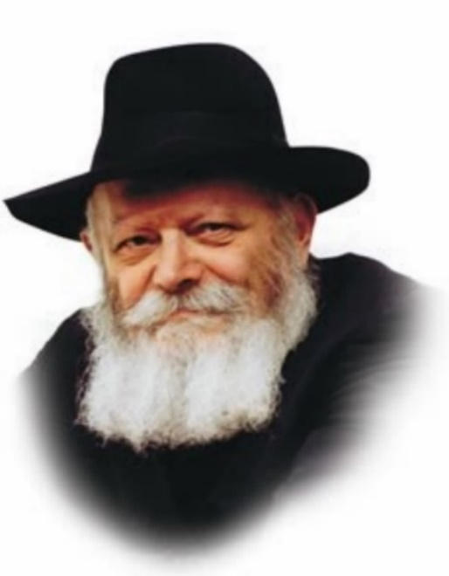

In the portion of Naso, the Torah commands the Jew to bring the first of his harvest to the Holy Temple. This is the mitzva of bikurim, first fruits, through which the Jew thanks G-d for His abundance.

But what is actually done with the first fruits after they are brought? The Torah states: "Every offering which they bring to the priest, shall be his." Our Sages explain that this means that the produce is to be given to the priests.

Why is the Torah so circuitous? Why does it instruct us to bring the first fruits "to the House of the L-rd," rather than telling us directly to give them the priests?

To explain:

The Torah's directive to bring the bikurim "to the House of the L-rd" is intended to establish the awareness that the first fruits do not belong to the individual, but to G-d. Their rightful place is therefore in the Holy Temple, G-d's "House." Once this fundamental principle has been acknowledged, G-d gives us the practical instruction of what to do with them.

The first fruits are the finest and most select portion of the crop, the result of a great deal of effort on the part of the farmer. For months he has worked the land and tended it carefully. Nonetheless, after all this exertion, the Torah commands him to bring the very best of his yield to the Holy Temple and give it to the priest.

In truth, the mitzva of bikurim contains a fundamental lesson to be applied in our daily lives, in all times and circumstances. It teaches that a Jew must always give G-d the first and best of all his labors. Whenever G-d grants us success and abundance, the finest portion must always be set aside for charity.

The Evil Inclination sometimes tries to dissuade us. It's only right to give charity to the poor, it may whisper, but why do we have to give the very best? Or, once the person accepts that he should part with his money, it tries to convince him to give it to a nameless institution rather than a specific individual.

Or if he already agrees to help the needy, the Evil Inclination might advise him to divide his money among many poor people rather than hand over the fruit of his labors to one person.

Therefore, the Torah makes it clear that a Jew must always remember that his "first fruits" belong to the "House of the L-rd your G-d." If the Evil Inclination tries to interfere with a person's good intentions, the reason is that he has not fully relinquished the claim on his material goods.

If he were to truly recognize that the money he gives to charity is not really his, he would not be troubled by these thoughts. The next step, of actually deciding where the money will do the most good will then flow naturally and easily, rendering him even more worthy of G-d's blessing.

*Reprinted from the Parshat Nasso 5760/2000 edition of L’Chaim. Adapted from Volume 8 of Likutei Sichot.*

**More Thoughts for the Parsha**

*And he who offered his offering the first day was Nachshon, the son of Amminadab, of the tribe of Judah* (Num. 7:12)

The order in which the leaders of the Twelve Tribes brought their sacrifices teaches the proper order of our Divine service: First came the tribe of Judah, from the Hebrew word meaning "to thank."

This is symbolic of the first step in worshipping G-d, humility and acceptance of the yoke of Heaven. Next came the tribe of Issachar, whom the Torah describes as "men of understanding." This alludes to the second step, the study of Torah. The third tribe to make its offering was Zevulun, about whom it states, "Rejoice Zevulun, in your going out." This is symbolic of the third step, the practical performance of mitzvot. (Addendum to Ohr HaTorah)

*Reprinted from the Parshat Nasso 5760/2000 edition of L’Chaim.*

**Rav Avigdor Miller on**

**Why is There So Much**

**Divorce in America**

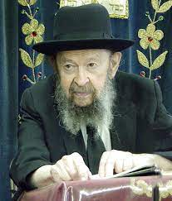

Why is there so much everything else in America? Why is there so much crime in America? What is there so much suicide in America? Among the youth, suicide is increasing rapidly. Why is there so much narcotics in America?

And the answer is America has thrown away its discipline, its law and order. The liberals have seized control of the media and they have ruined the nation. We have to worry what’s going to be in twenty years from now when the ruined youth will become the judges.

Even today we have terrible judges who are the result of the 1960’s; criminals who are sitting in black gowns. These criminals are the result of the 1960 youth, the rebels. What’s going to be twenty years from now? America is in a very bad state and it’s important we should do something about it.

So therefore, what’s wrong with America is that they are raising up generations of dragon’s teeth; we’re going to sow a crop that’s going to be chas v’shalom a disaster. The children in public schools today are being ruined by an education that promotes disorder and immorality, and divorce is merely one phase of the decay of American society.

*Reprinted from a recent Toras Avigdor email based on Rabbi Miller’s Tape # 506 from a classic Thursday night lecture in April 1984.*

**OU Kosher Centennial Spotlight:**

**Nathan K. Gross (1911-1985)**

**By Rabbi Julius Berman**

[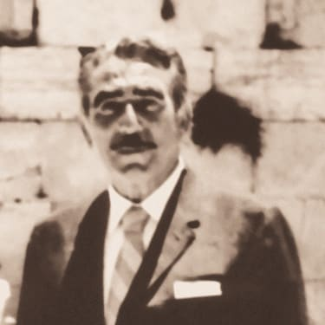](https://res.cloudinary.com/ouwp/images/w_2560,h_2560/f_auto,q_auto/v1679404265/Jewishaction/SEPIA-Centennial-Spotlight-Nathan-Gross-Photo/SEPIA-Centennial-Spotlight-Nathan-Gross-Photo.jpg?_i=AA)

With 2023 marking 100 years of OU Kosher, throughout the year, Jewish Action will profile personalities who played a seminal role in building OU Kosher, the largest and most widely recognized certifying agency. We hope to focus on Rabbi Berel Wein and Rabbi Yacov Lipschutz in a future issue. The article below is adapted from a profile that appeared in the spring 1998 edition of Jewish Action.

Business in the Orthodox Union Kosher Division is booming. The phones are ringing off the hook and e-mails are piling up, as each day brings in more and more applications for OU certification.

Our multimillion-dollar computer system is in place, and the programmers are entering the kashrut status of thousands of ingredients. Hundreds of mashgichim are out inspecting manufacturing plants located in countries all over the world. The ubiquitous OU symbol can be found on thousands of products almost anywhere one travels. Many of the largest and best-known brands—Nabisco, General Mills, Nestle, Hershey’s, M&M and Coca-Cola, to name a few—are tied to the OU symbol.

How did all this come about? It can safely be said that one man, with unique ability, dedication and persistence, consumed with a sense of mission, played the leading role in the development of kashrut certification, first in America and then throughout the world. That man was Nathan K. Gross, z”l.

Nat was born in Brooklyn on June 16, 1911. His father was American-born and his mother came to the US as a small child. Nat was college educated and had a law degree. He played a significant role in a wide range of communal activities. For example, he served for many years as the president of Congregation Ohab Zedek in Manhattan and was deeply involved in supporting Beis Avrohom, the Slonimer Yeshivah in Israel. He was also very close to the Slonimer Rebbe. But the crowning achievement of his communal labors was unquestionably his critical contribution to establishing kashrut supervision in America on a solid basis during the years between 1950 and 1984, when he served as chairman of the OU’s Kashruth Commission.

**Popularly Referred to as “Mr. Kashrut”**

The name Nathan K. Gross is inextricably linked for all time with the growth of kashrut certification. Nat—or, as he was popularly referred to, “Mr. Kashrut”—was a legend in his time.

And yet, the shidduch between Nat and kashrut was odd, to say the least. It surely does not appear, at least on the surface, to have been a match made in heaven. For all his wisdom, Nat had little formal religious education. The sophisticated and detailed intricacies of the laws of kashrut were not part of his academic upbringing. Nor, for that matter, did any phase of his education, either formal or informal, touch on the increasingly complicated field of food technology.

Moreover, the protracted contract negotiations with prospective companies applying for certification, as well as the constant soothing of egos that was required in his position as chairman of the OU’s Joint Kashruth Commission for so many years, seemed to contradict his activist personality.

**The Perfect Match for the Challenges Facing**

**Our Community in the Mid-20th Century**

But when we delve beneath the surface, it becomes evident that Nat’s unique talents, combined with his understanding of the special needs of kashrut certification, were the perfect fit to meet the challenges facing the American Jewish community in the mid-twentieth century.

To appreciate this apparent anomaly, we have to travel back to the ‘40s and ‘50s and take an honest look at the status of kashrut in America at that time.

There was virtually no kashrut supervision, and even when there was, anarchy often prevailed. The certification process was in large part—but, fortunately, not entirely—in the hands of individuals who were less than models of knowledge, commitment or integrity. One need not be an expert in the laws of kashrut to sense the cynicism concerning kashrut certification in both the manufacturing and consumer areas that were all too prevalent in the kosher food market.

Nat accepted the challenge and made it his task to bring order and integrity to the process. With his characteristic clarity of vision, he recognized the enormous impact the availability of kosher products could have on an emerging Orthodox Jewish community.

On a personal basis, Nat concluded that kashrut was the perfect vehicle through which he could express his love of his people and his religion along with his vision of a dynamic age of Jewish communal ascendency in America.

To this task, Nat brought his very considerable gifts of energy, integrity, patience and the rare quality of diplomacy. It was as a diplomat that he was at his best. It was a joy to sit back and watch him apply this G-d-given talent—an art that he had developed over the years—to the personalities on all sides of the table.

**The Delicate Balance when Negotiating**

Whether it was the rabbinical personage who held one view, the manufacturing representatives sitting across from him or the manufacturing plant manager who approached the negotiating table with trepidation and concern that some black-frocked, bearded rabbi quoting ancient, foreign tomes was going to hamstring his plant routine and make life unbearable, Nat was equipped for the challenge. His style was unique: more compromise than confrontation but always bearing in mind the goal he wished to achieve.

When the subject was a halachic matter, he was stolidly unyielding, impacted in large part by his awe of Torah learning. But at the same time, he had an almost radar-like instinct for knowing when to defer to rabbinical authority and when to separate politics and administration from the spiritual.

Nat Gross, in his own way, was a gadol hador. His work left a lasting impression on Jewish communal life, and the community will remain forever in his debt.

**Reflections from Rabbi Menachem Genack**

“Nathan Gross was the chair of the OU’s Kashruth Commission for many years. He was an astute businessman of deep integrity who refused to allow the OU’s decisions to be tainted by financial considerations. When I came to the OU, he was the elder statesman who guided us, and his advice was always on target. Everyone who met him immediately saw his great dignity; he was the consummate gentleman.

“At the time I took on the position of rabbinic administrator of the OU Kosher Division, our most significant company was Procter & Gamble. Each year, we would meet with Marshall Pollock, an executive at Procter & Gamble, to negotiate our contract for the coming year. I could see how highly Marsh regarded Nat—his dignity and intelligence shone through. He was the essential piece in this partnership and in many others the OU developed. The growth of the OU over the last decades would not have been possible without Nat Gross’s leadership.”

—Rabbi Menachem Genack, CEO, OU Kosher

Rabbi Julius Berman is a former president of the OU and a former chairman of the OU Kashruth Commission.

*Reprinted from the* [*Spring 2023*](https://jewishaction.com/issues/spring-20235783/)*issue of Jewish Action, a quarterly magazine of the Orthodox Union.*

**1,100-Year-Old Tanach Sells For**

**$38 Million At New York Auction**

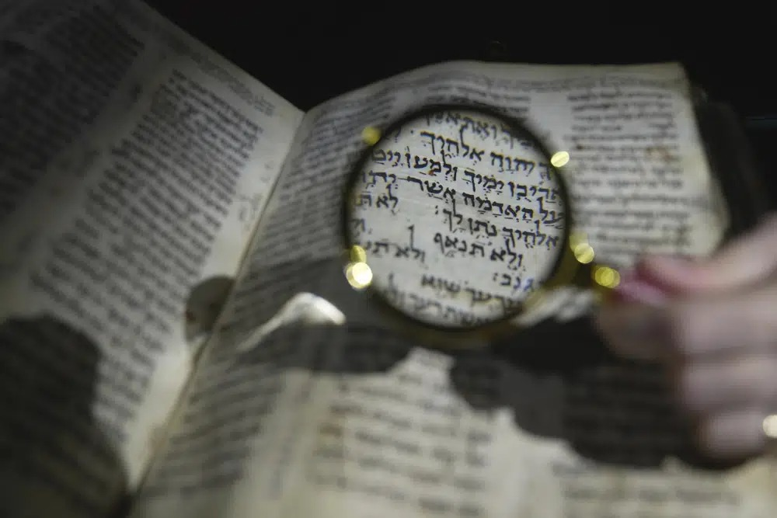 **(AP Photo/Kin Cheung)**

A 1,100-year-old Tanach (Jewish Bible) that is one of the world’s oldest surviving biblical manuscripts sold for $38 million in New York on Wednesday, May 17th

The Codex Sassoon, a leather-bound, handwritten parchment volume containing a nearly complete Hebrew Bible, was purchased by former U.S. Ambassador to Romania Alfred H. Moses on behalf of the American Friends of ANU and donated to ANU Museum of the Jewish People in Tel Aviv.

The manuscript was exhibited at the ANU Museum in March as part of a worldwide tour before the auction.

Sotheby’s Judaica specialist Sharon Liberman Mintz said the $38 million price tag, which includes the auction house’s fee, “reflects the profound power, influence, and significance of the Hebrew Bible, which is an indispensable pillar of humanity.”

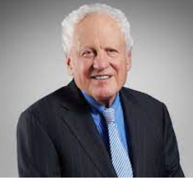

**Alfred H. Moses**

It’s one of highest prices for a manuscript sold at auction. In 2021, a rare copy of the U.S. constitution sold for $43 million. Leonardo da Vinci’s Codex Leicester sold for $31 million in 1994, or around $60 million in today’s dollars.

Mintz said she was “absolutely delighted by today’s monumental result and that Codex Sassoon will shortly be making its grand and permanent return to Israel, on display for the world to see.”

The Codex Sassoon is believed to have been fabricated sometime between 880 and 960.

It got its name in 1929 when it was purchased by David Solomon Sassoon, a son of an Iraqi Jewish business magnate who filled his London home with his collection of Jewish manuscripts.

Sassoon’s estate was broken up after he died and the biblical codex was sold by Sotheby’s in Zurich in 1978 to the British Rail Pension Fund for around $320,000, or $1.4 million in today’s dollars.

The pension fund sold the Codex Sassoon 11 years later to Jacqui Safra, a banker and art collector, bought it in 1989 for $3.19 million ($7.7 million in today’s dollars). Safra was the seller on Wednesday.

Reprinted from a May 17, 2023 dispatch of the Associated Press, (AP)